Saurav Shrestha

[company name]

Trader (Oracle) Guideline

[Document subtitle]

Trader (Oracle) Guideline

1. First, user needs to login from the customer login section and select ‘Trader’ from the given choices of roles.

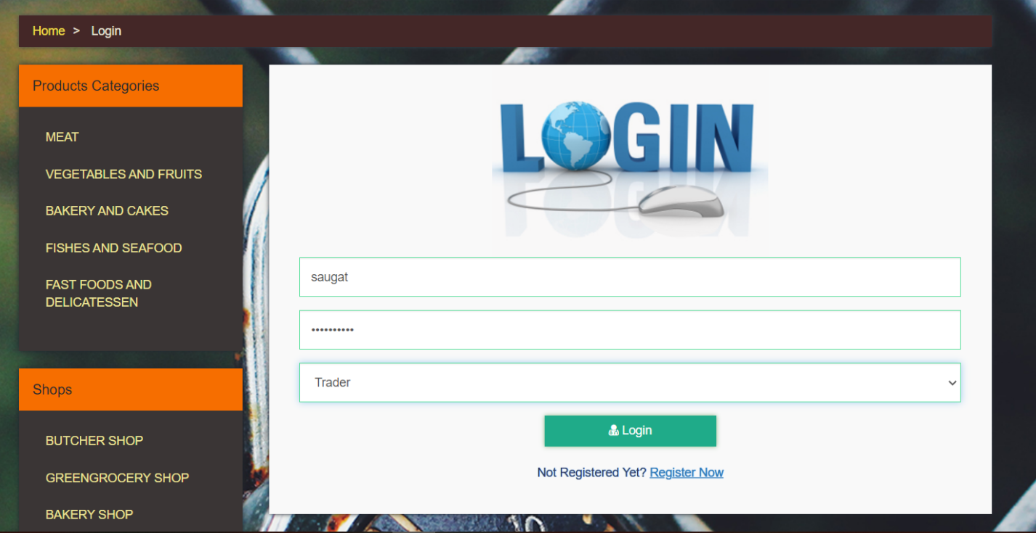

1. If the login succeeds, then the user will get redirected to the backend dashboard for the trader.

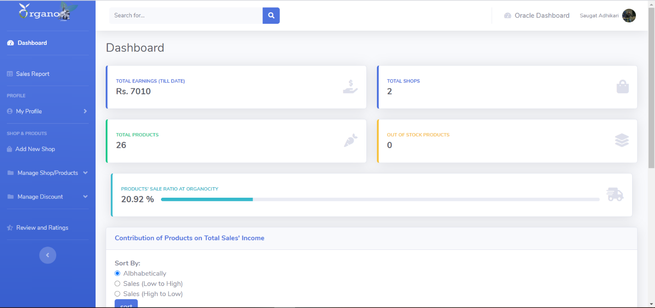

1. In the backend dashboard, the user can click on ‘Oracle Dashboard’ link on the top bar of the page to get get redirected to the oracle login.



1. Error will be displayed if attempt to log in is made without entering Username or Password.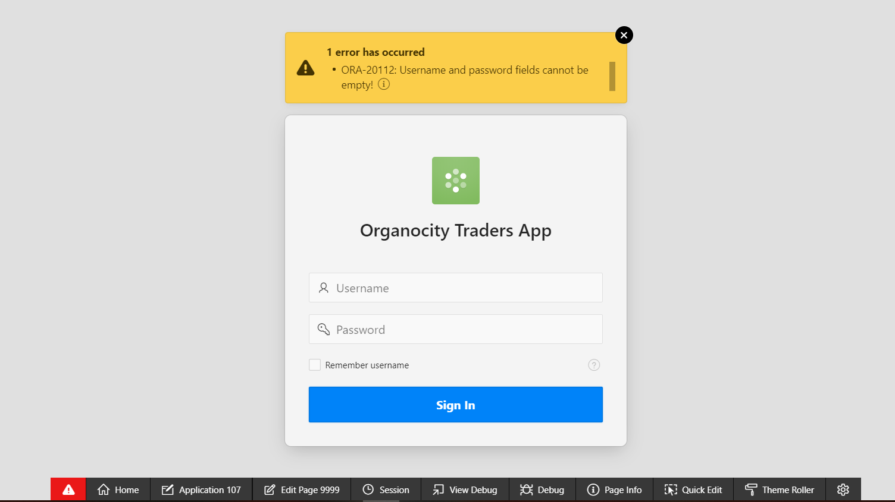
2. Error message is shown when invalid credentials are entered while attempting to log in. 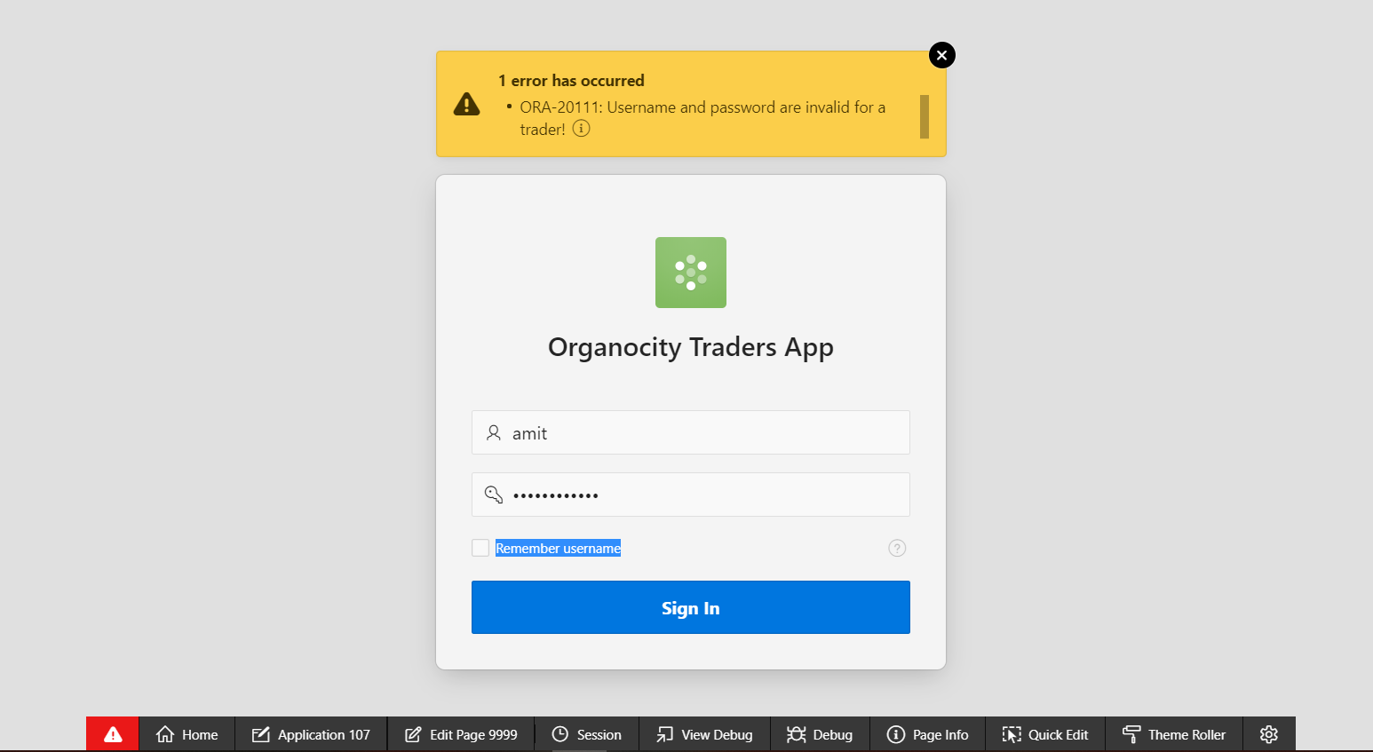
3. The Trader will again need to enter the correct credentials to enter the trader dashboard. These credentials will be the same as what they use to login to their backend dashboard.

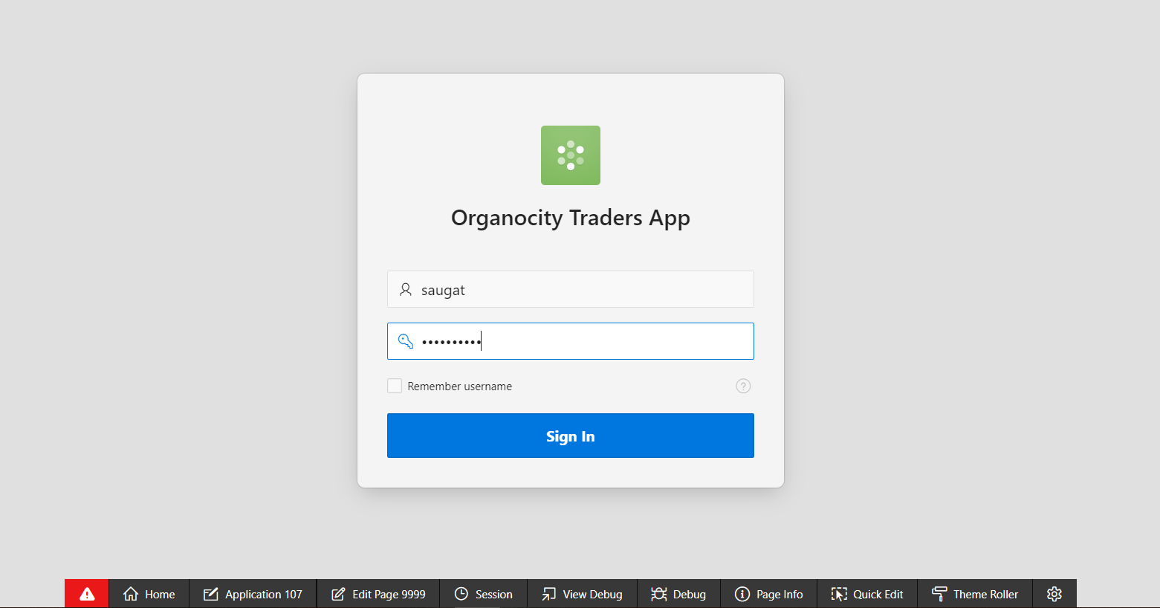

1. The traders will be able to view their respective monthly totals sales, total number of customers from the dashboard.

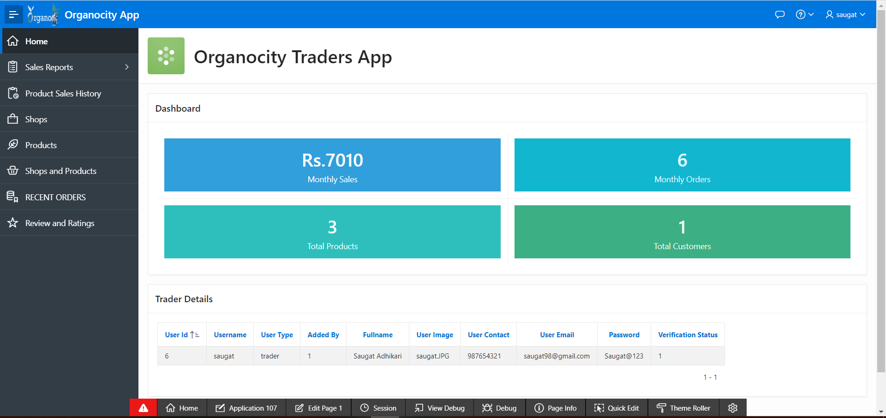

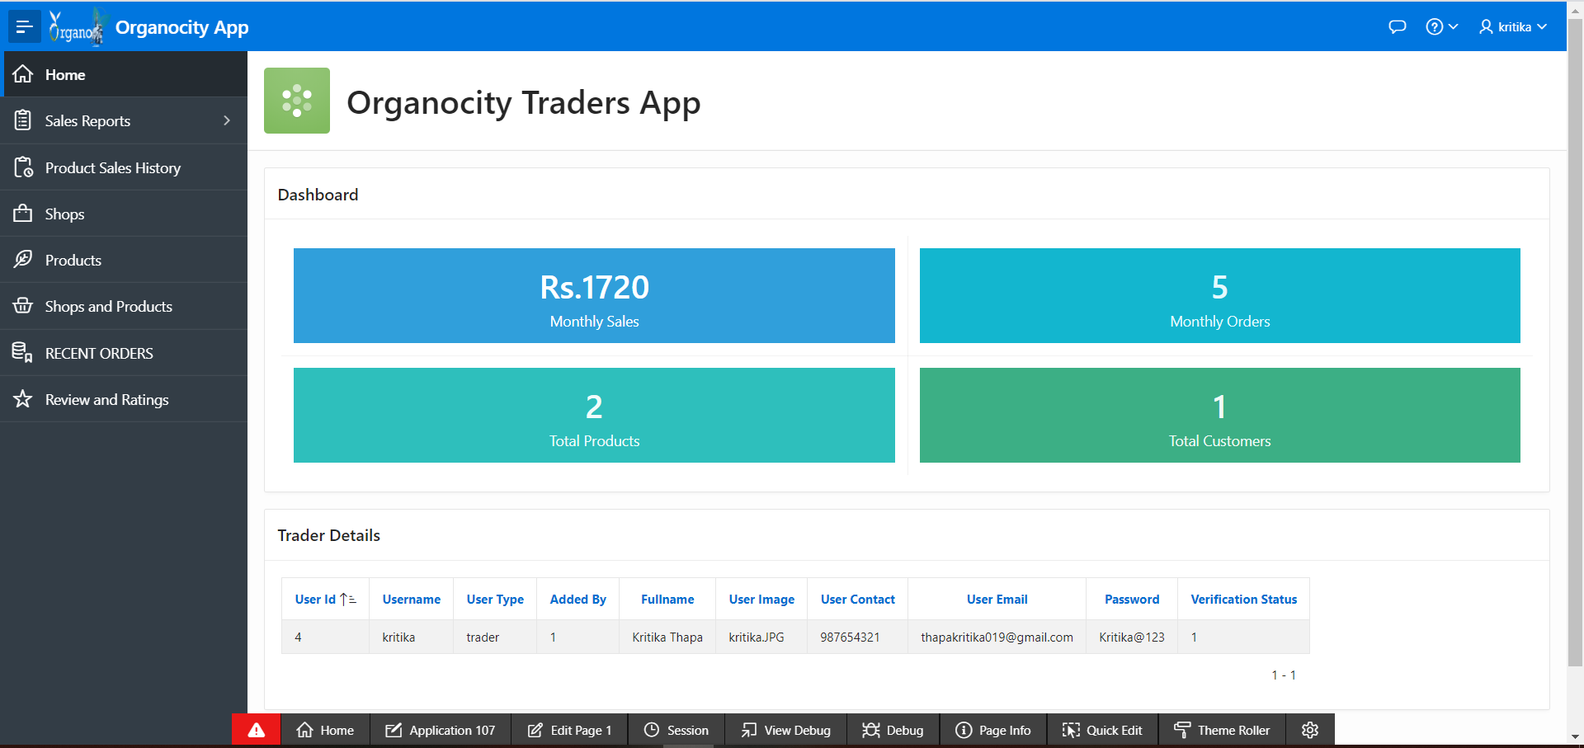

1. Traders will be able to view their respective weekly, monthly and daily sales reports of products they sell.

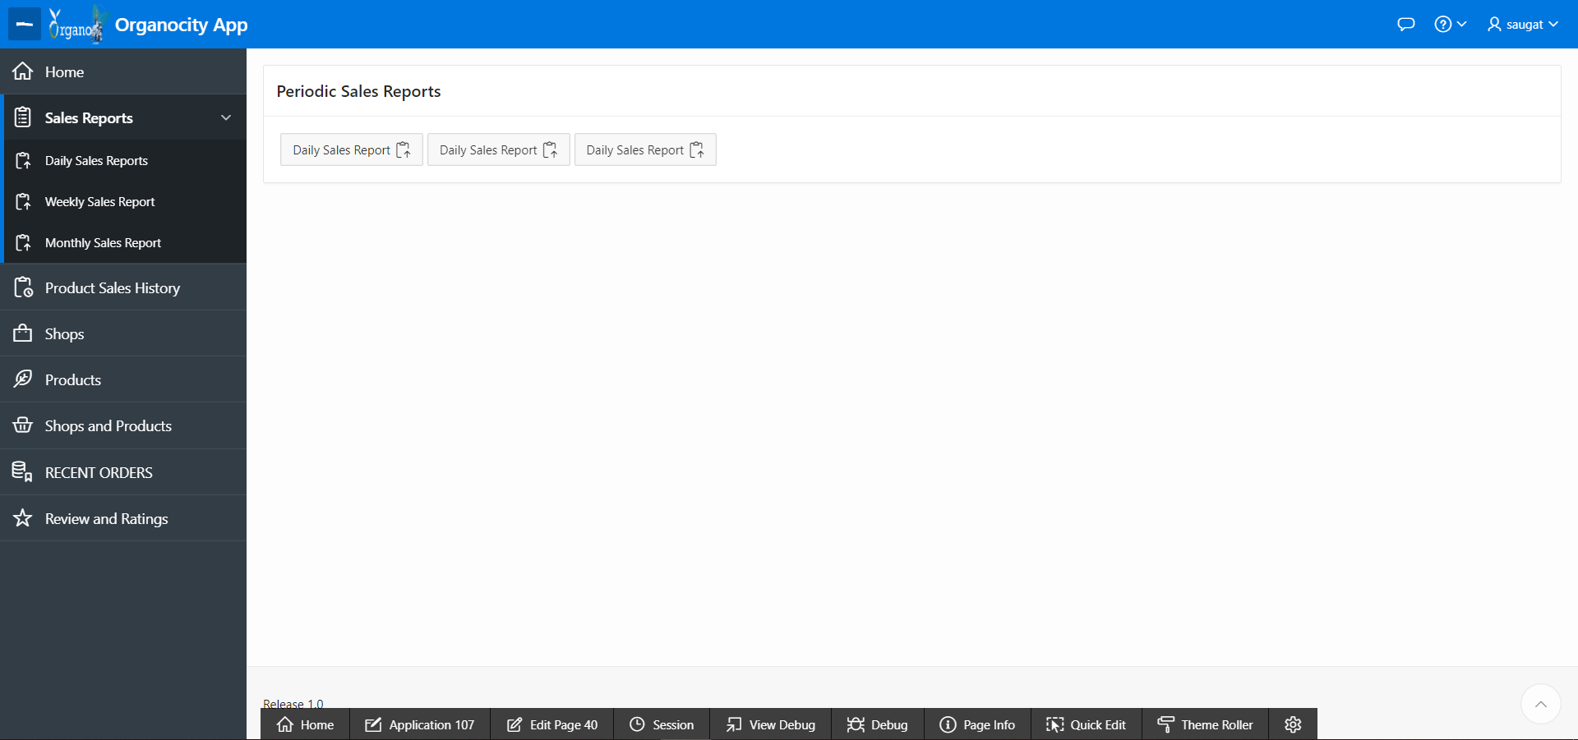

1. Weekly Sales Report

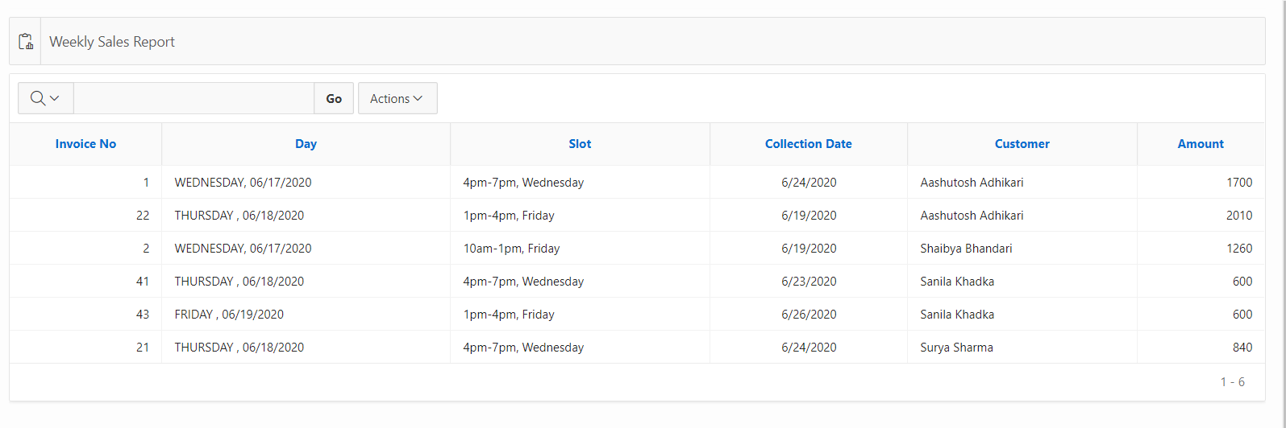

1. Monthly Sales Report

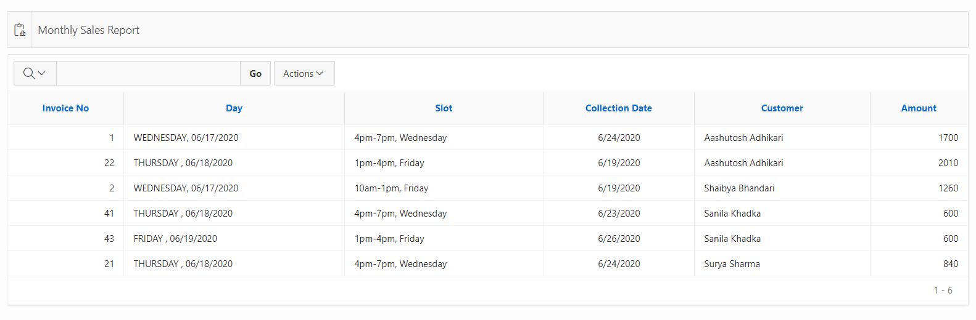

1. Daily Sales Report

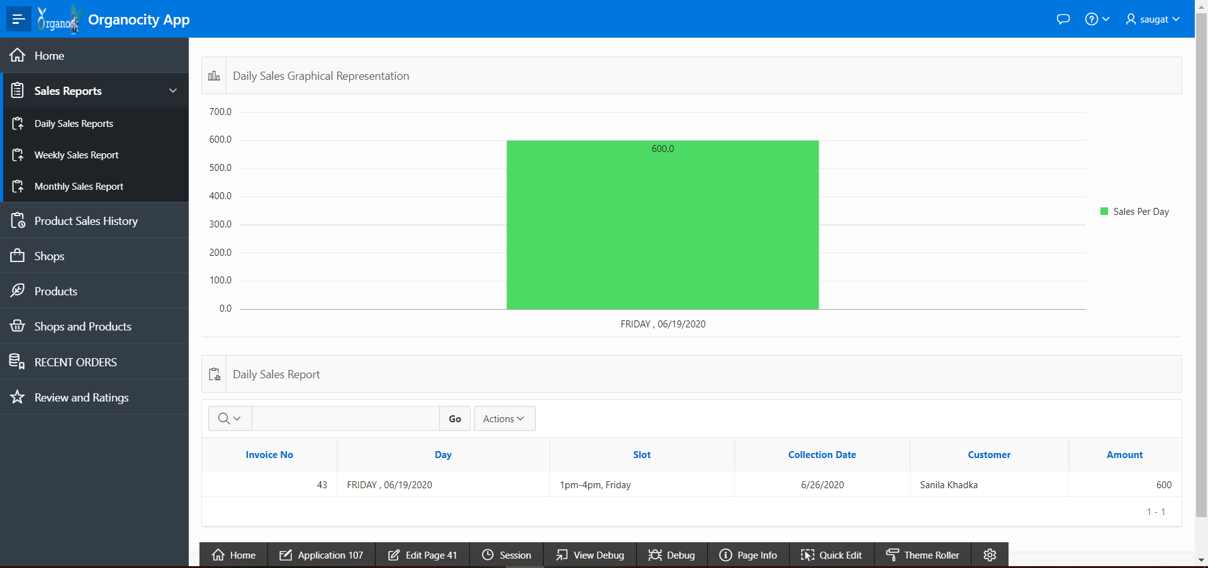

1. Charts and Graphs of Sales are also displayed
2. Weekly Sales Bar Graph

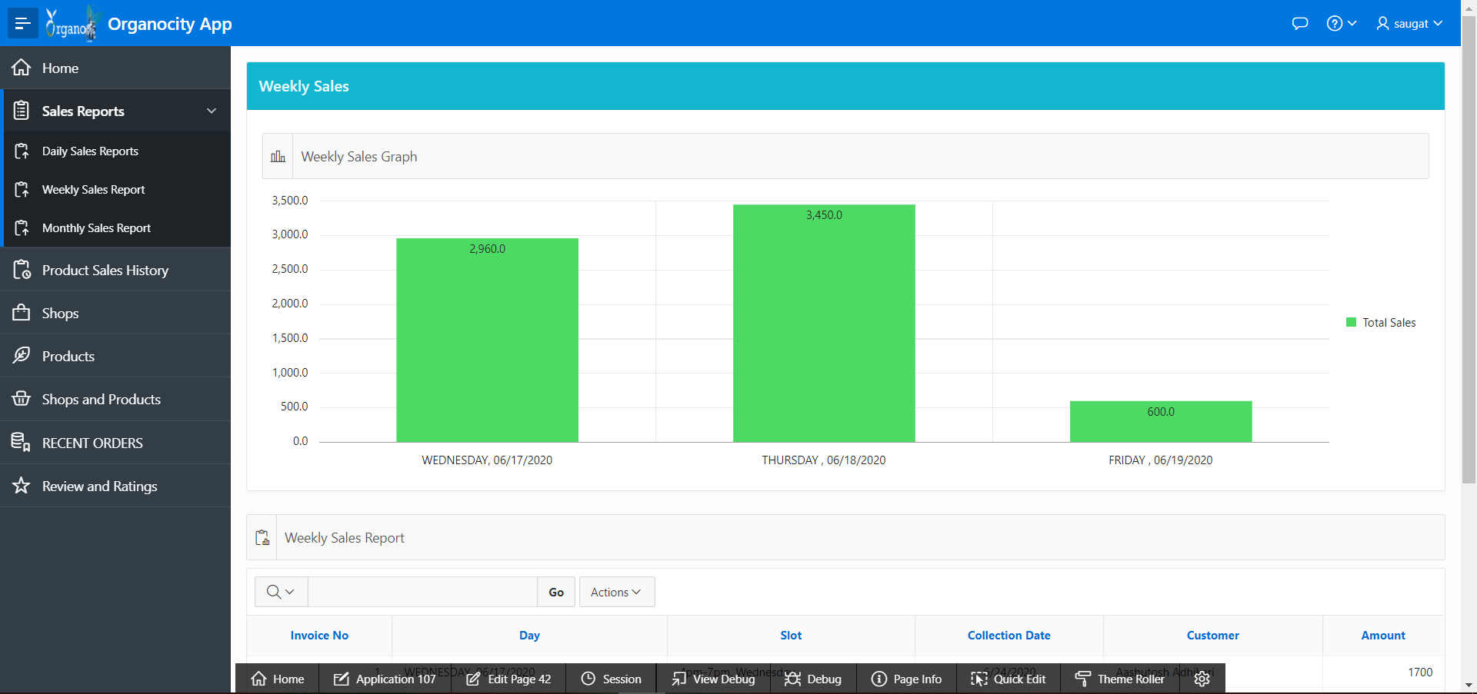

1. Monthly Sales Bar Graph

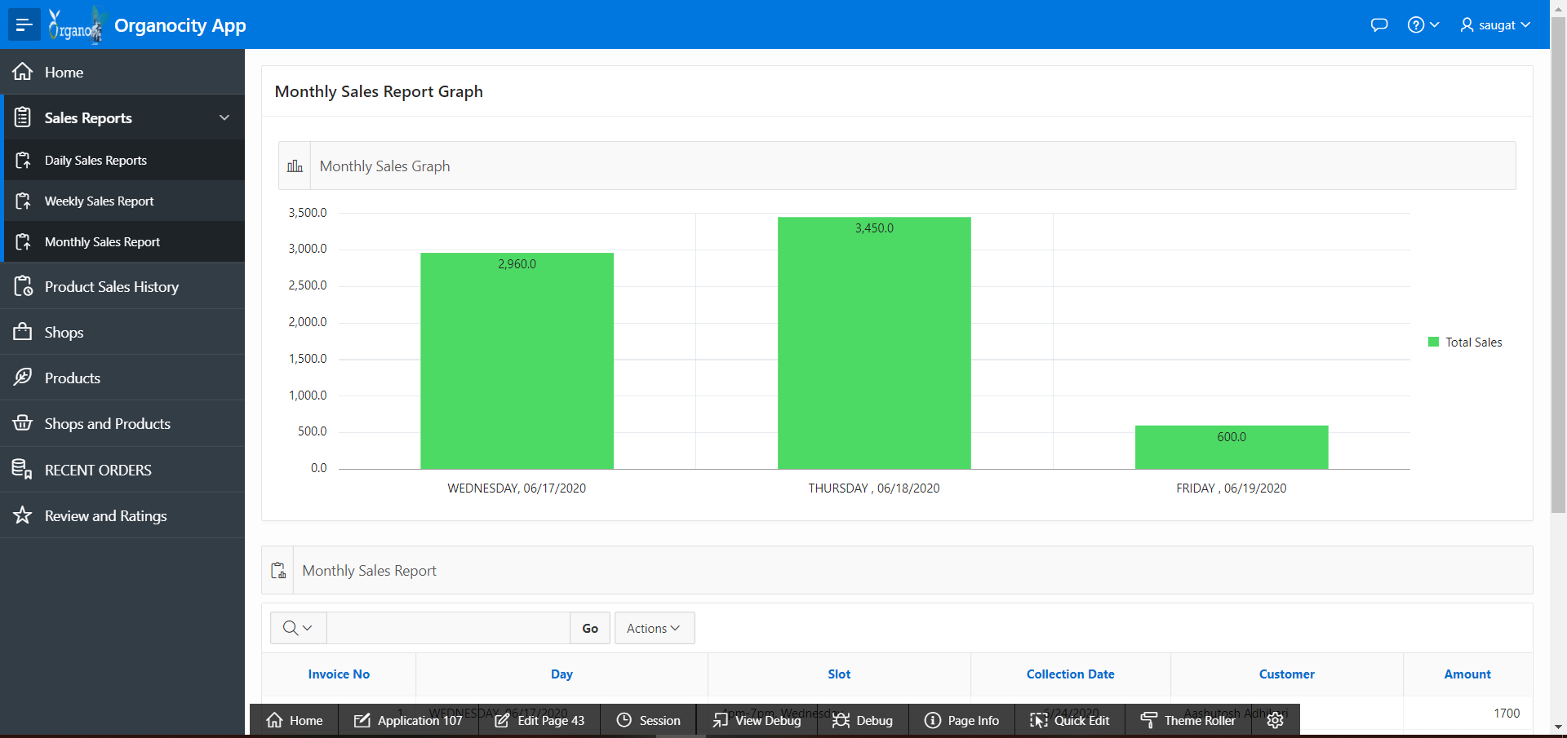

1. Daily Sales Bar Graph



1. Traders can also see the history of all their respective products that they have sold.

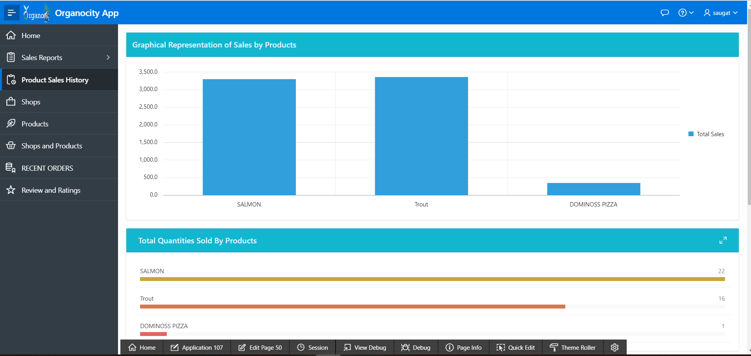

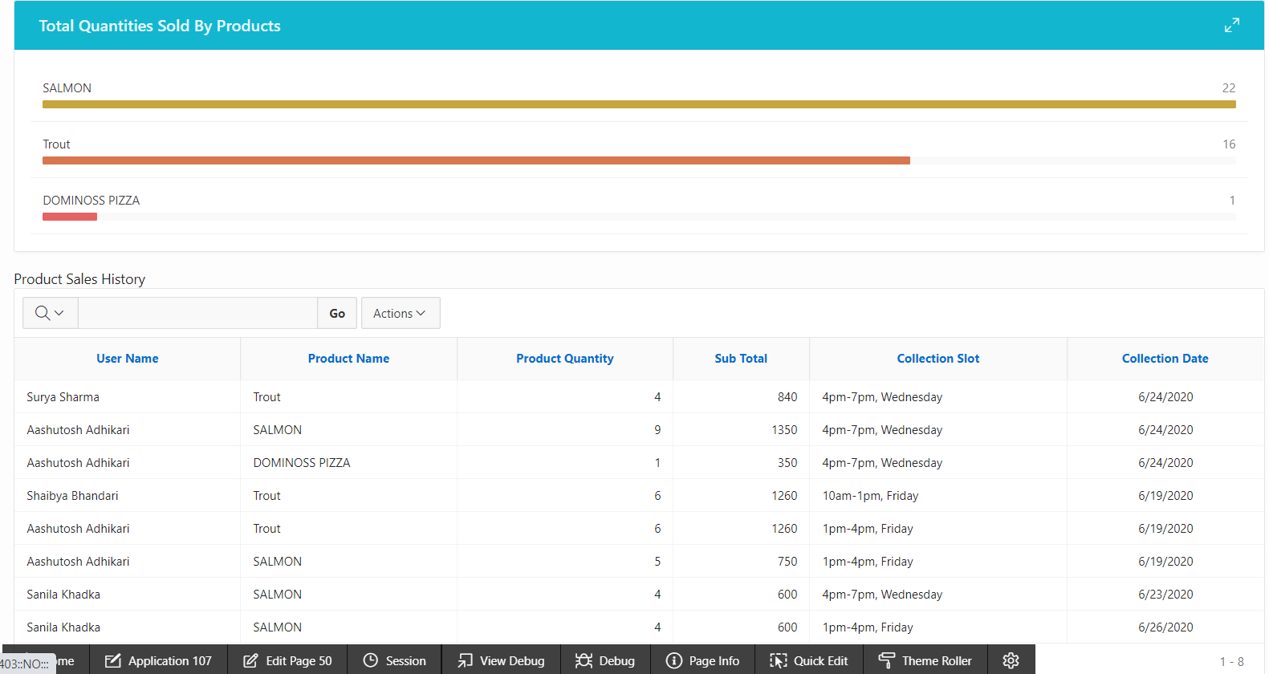

1. Traders can manage or add their shop (1 or many).

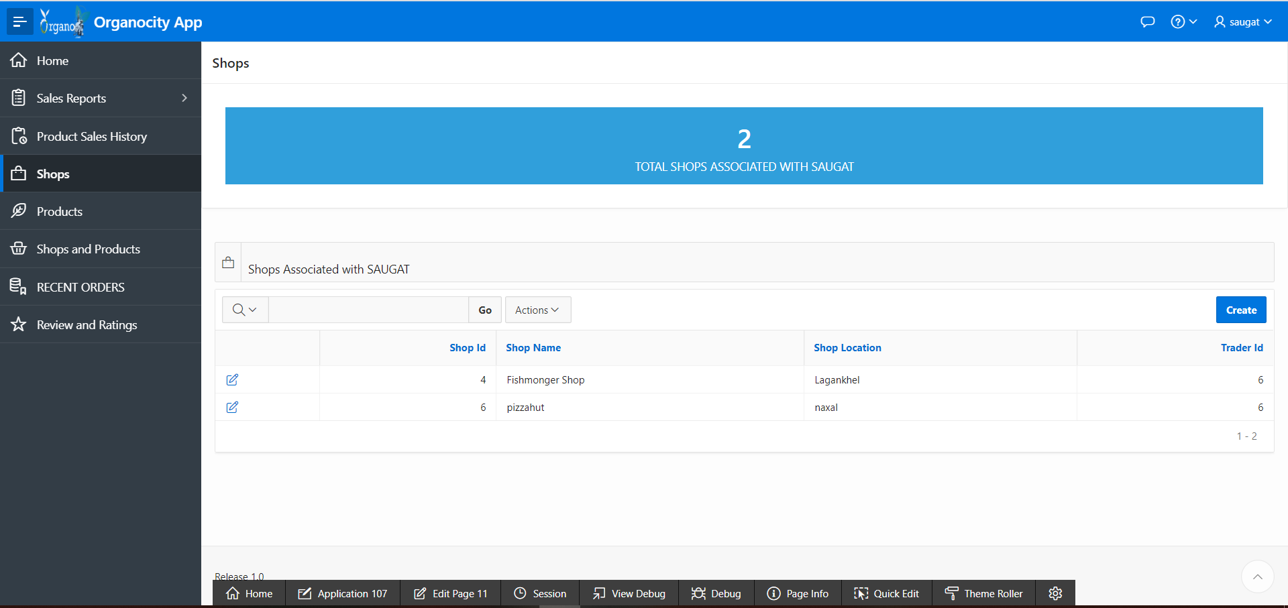

1. Products of stores the traders own, is also managed through oracle.

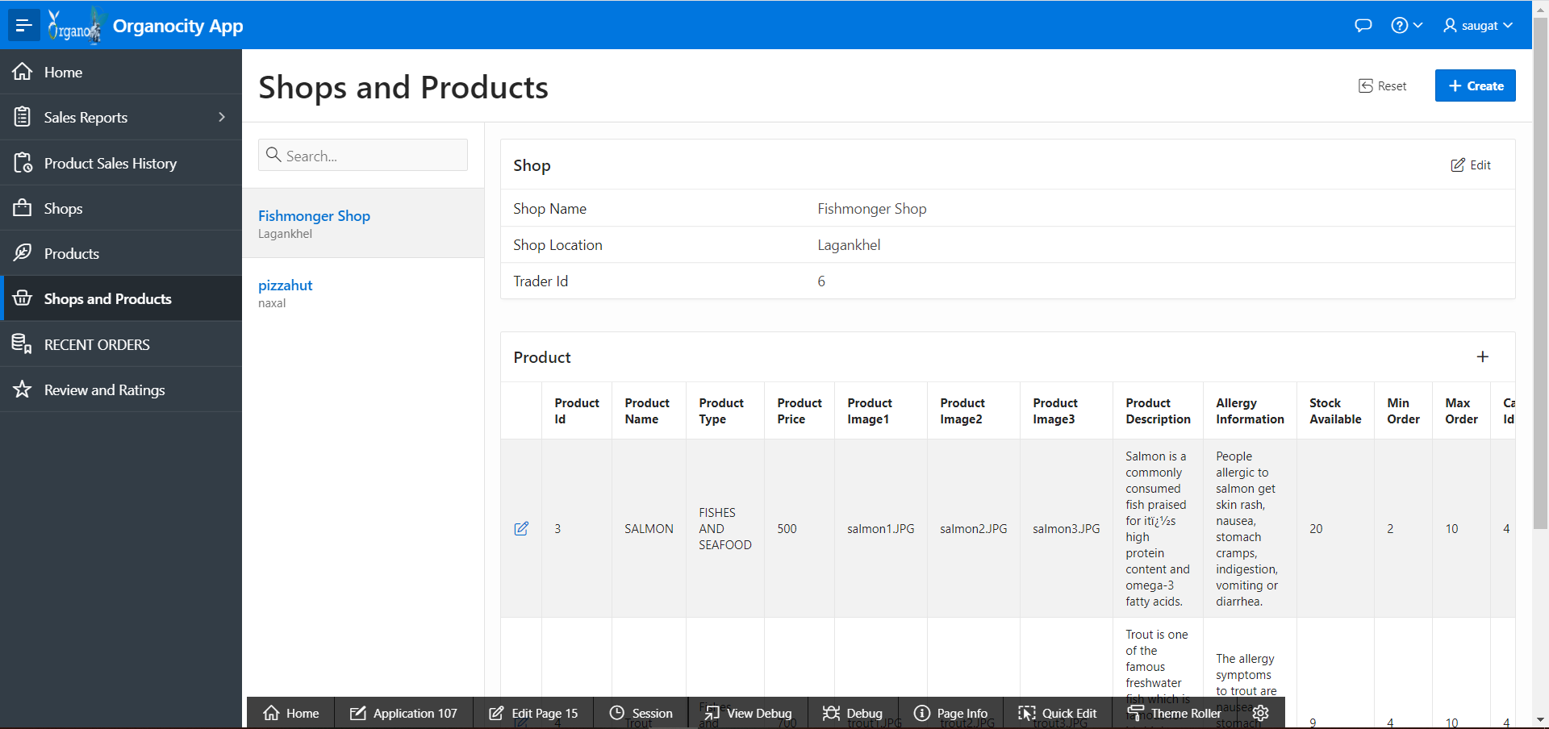

1. Traders can view their shop along with the products available in that specific shop.



1. Traders can see a list of all recent clients as well.

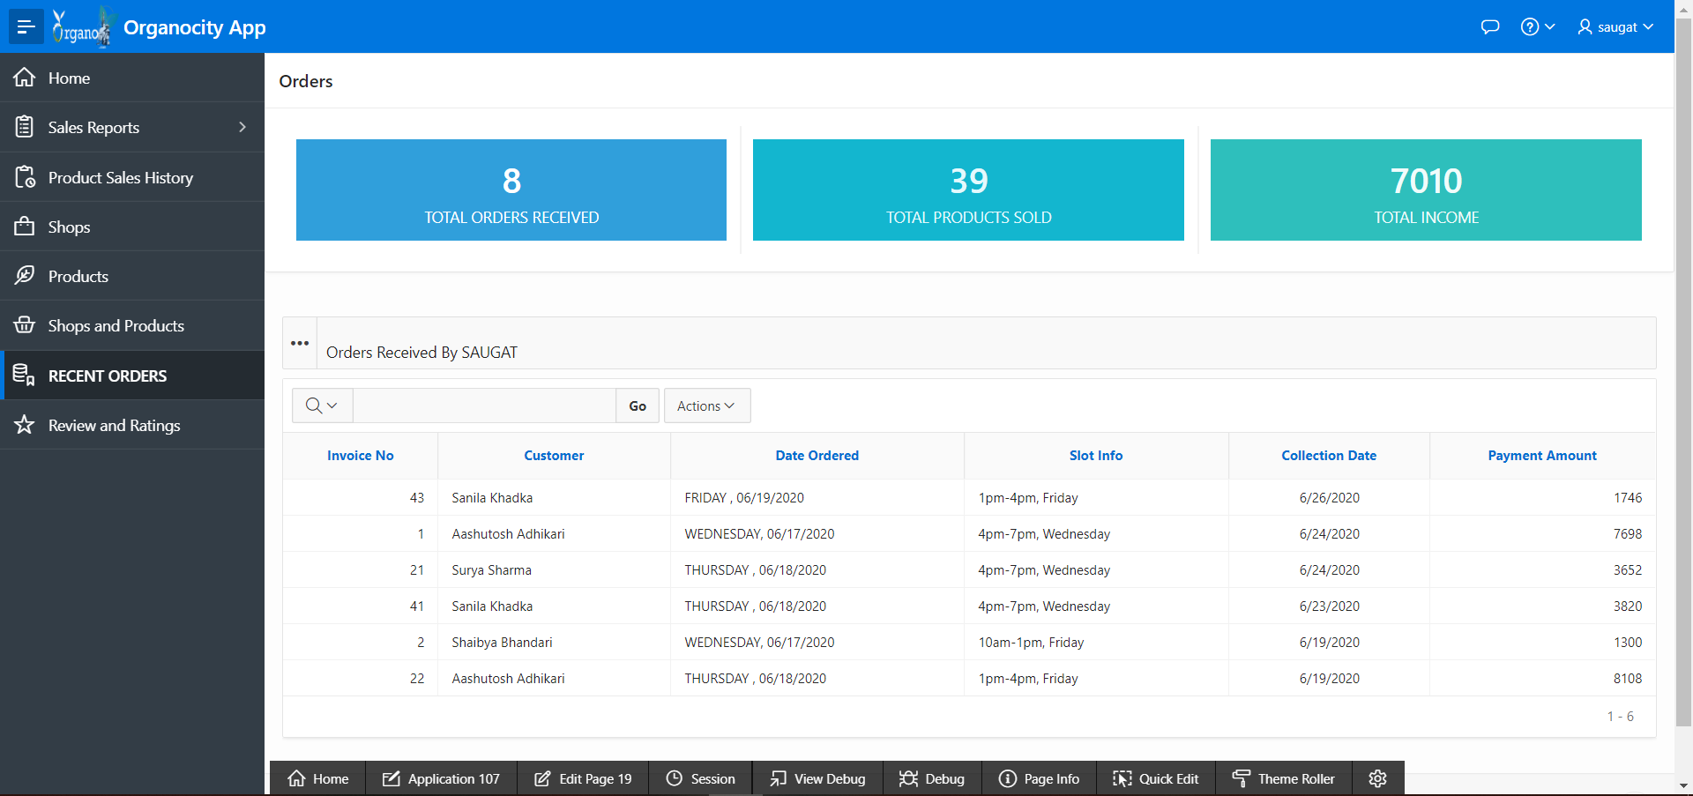

1. Reviews that customers make on products can also be viewed by the trader.

